PicChat
CS1530 Sprint 1-Deliverable 1
Due Date: June 10th 2015

Team Members:
Blaise Clair - Product Owner
Andrew Harper – Software Developer
Neel Kowdley - Software Developer
Dom Grigore - Quality Assurance Manager

Project Description
Client: Nate Thompson

Name of Project: PicChat

Description: The client for this project wants us to create a map-centric social media platform. A user will log in, and be able to create posts and content by providing a location and the content itself. The content will then be place on a map, so that other users can view activities and posts at a specific location and be able to find activities to do at certain locations.

This project will be created as a website, and hopefully be compatible with mobile browsers.

Project Github Page: https://github.com/nkowdley/CS1530-Team9

Design Mock-up:
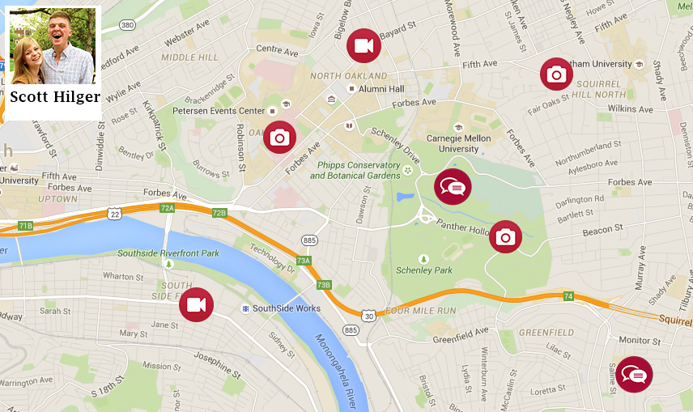

User Stories and Backlog:

How User Stories are Developed:
We developed our User Stories for this sprint by first, discussing the project with the client. We communicated extensively with our clients, and from our meetings with them, we were able to determine a list of requirements based on the clients needs.

We were able to come up with User Stories by evaluating each requirement, and determining which person in the development and use in the project would benefit from the requirement.

Priorities for each user story were determined by a number of characteristics:
1) If a user story “blocked” other user stories or backlog items. This would occur if one user story is dependent on, or unable to be worked on until another story being completed. The “blocking story” should be given a higher priority.
2) How integral the user story is to the client. If the user story is important to the client in the overall product, it should have a higher priority.
3) How much benefit would be gained from completing the project. If the user story is contains a major feature, it should have a higher priority.

Current User Stories
Our User Stories, ranked by priority is in the table below.

The columns of the table are defined as follows:
Priority: How valuable the the user story is to the overall product.
User Story Number: Our internal numbering scheme in order to keep track of User Stories.
User Story: The contents of the User Story, in the Connextra format.
Points: How long we anticipate this user story will take to complete.

Priority | User Story Number | User Story: | Points
1 | 1 | As a user, I want to have a Maps interface with locations of posts marked, so that I am able to view where my friends are when they make posts. | 16
2 | 2 | As a developer, I want a back end database so that I can easily store and retrieve data about posts. | 8
3 | 16 | As a user, I want to be able to make text posts with the location of the post, so that I can create content for people to see. | 8
4 | 3 | As a user, I want the ability to upload photos, so that I can share cool pictures with their locations for my friends to see. | 8
5 | 4 | As a user, I want to be able to log onto the site with a profile, in order to save my settings and preferences. | 2
6 | 5 | As a user, I want to be able to search by location and by user name, in order to filter the amount of posts visible on my screen. | 8
7 | 15 | As a user, I want my location to automatically be determined, so that I do not have to select a location each time I post. | 4
8 | 14 | As a user, I want to select the location of my post, so that I can choose where it gets displayed, if no location is able to be determined. | 2
9 | 13 | As a user, I want to be able to choose whether I want to share my location or not, so that I can keep my whereabouts private | 2
10 | 11 | As a user, I want a clean and easy to understand User Interface, so that I can easily use this site, without needing help. | 8
11 | 6 | As a user, I want the ability to initiate a chat with my online friends, so that I can communicate on one platform. | 16
12 | 7 | As a user, I want a translator, so that I can read posts from people all over the map. | 1
13 | 8 | As a user, I want the ability to convert currency easily, so that I can determine costs if I see them for places all around the map. | 1
14 | 9 | As a user, I want to quickly view the weather, so that I can make plans based on what occurs on the map. | 1
15 | 17 | As a tester, I want a large number of photos with location data, so that I can verify locations are pulled correctly from photos. | 1

Testing:

For the testing aspect of the project, there were multiple aspects that can be tested automatically through scripts and some aspects that are better suited to manual testing. As this application will not be written in Java, Junit will not be the testing framework used. Since many components of the application will use JavaScript, QUnit will be the unit testing framework for our automated tests.

With regards to functional aspects of testing, almost all of the planned functionality will need to be tested. For example, unit tests for testing the database would include adding photos to the database, removing photos from the database, adding a text post under a user, removing a text post from a user, etc. Unit tests will also be useful for the login functionality, search tool, map navigation and viewing posts and photos, as all of these components will be JavaScript based and testable through QUnit.

Some aspects of this project will likely need to be tested manually, as they are either not written in JavaScript or there are too many variables to account for when creating a test. An example of this would be the chat functionality. Since there would need to be two users logged in at the same time on different machines and both machines would need to have synchronized tests, it would be more efficient to test and verify chatting manually.

Testing non-functional aspects of the project will likely be completed manually. Performance, usability and security are all non-functional aspects that need to be tested. For performance, the system will need to be tested with regards to response times, processing times, and query times. For usability, the system’s UI, screen element density, layout, look and feel will all need to be tested within the group and with the customer. Security-wise, the system’s security requirements, such as login information storage and inactivity timeout, will need to be tested manually.

Team Decisions:

This project initially posed many problems and decisions that our team had to make in order to proceed in creating the product. We were not given many restrictions on the technologies that we would be allowed to use. This opened up a lot of possibilities for the best way to approach the problem. The major decisions we faced regarding which technologies to use are presented below:

